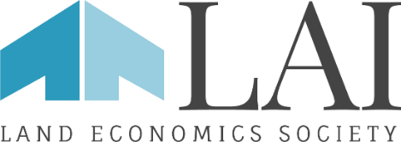
AWARDS NOMINATIONS

Lambda Alpha International Awards are presented on the schedule given below to honor nominees who have notably advanced the field of land economics through their achievements and service to their profession, community and chapter. Awards are presented during LAI’s two annual Land Economics Weekends (LEW’s) events.

AWARD Categories and nomination deadlines
Odd NUMBERED years | EVEN NUMBERED YEARS
SPRING LEW, nominations due March 15th  - International Skyline Award  (if desired by the host LEW Chapter) | SPRING LEW, nominations due March 15th  - International Skyline Award  (if desired by the host LEW Chapter)
FALL LEW, nominations due July 1st  - International Urban Affairs/Public Official Award  - International Member of the Year Award  - International Skyline Award  (if desired by the host LEW Chapter) | FALL LEW, nominations due July 1st  - Richard T. Ely Distinguished Educator Award  - International Member of the Year Award  - International Journalist/Author Award  - International Skyline Award  (if desired by the host LEW Chapter)

AWARD ENTRIES

Please complete the attached form (maximum 2 pages) for each nomination for each award. In the case of the Skyline Award, you may provide additional supporting material in the form of photos or maps via email to facilitate our distribution to the Awards Committee for their review. Please send nominations and any supporting material to lai@lai.org.

AWARD PRESENTATION
LAI awards will be presented at LAI Land Economics Weekends. LAI will pay for travel expenses for awardees as follows:
Public Official/Urban Affairs, Journalist/Author and Ely Distinguished Educator Awards
- Airfare (round-trip economy class) to the site of the Land Economics Weekend for the awardee and one guest (spouse, partner, friend, family member or significant other)
- One hotel room for three nights at the conference hotel
- Registration to the entire LEW for both awardee and spouse
Member of the Year and Fellow award recipients:
- LEW registration for the awardee and one guest (spouse, partner, friend, family member or significant other)
- No other expenses
Skyline Awardees:
- LEW registration only for two persons to be selected by the awardee
- No other expenses

CATEGORIES OF AWARDS

International Member of the Year Award
This award is selected from Chapter nominations of Chapter Member of the Year honorees for the current or prior year by the International Awards Committee and will be based upon commitment to Lambda Alpha, to the nominee’s profession and to land economics with respect to achievement in the private or public sectors, research or education. For chapters that do not make a Chapter Member of the Year award, the justification should make a strong case for nominating the person for this award. Awarded to LAI members only.

International Public Official/Urban Affairs Award
This award is presented either to a public official who, through his or her efforts—technical, managerial or other significant effort—has made a notable contribution to improving the quality of urban life or to a person who has made outstanding contributions to urban affairs and who has advanced the frontiers of knowledge via research and/or practice.

International Journalism/Author Award
This award is presented either to a journalist or an author whose efforts have contributed to a greater understanding of the principles, practices and greater awareness of land economics. The journalism award is for a sustained, exemplary contribution to a national or regional body of work. The author award is for an exemplary book length publication.

Richard T. Ely Distinguished Educator Award
This award is presented to the person who has achieved excellence within the academic world in the field of land economics or one of its constituent disciplines by leadership in teaching, research or mentorship.

International Skyline Award
This award will recognize a project or policy identified by the host Land Economics Weekend (LEW) Chapter and vetted by the International Awards Committee. It is a discretionary award and will be presented at each LEW only if the host chapter identifies a project, making their choice known to the International Awards Committee at least six weeks prior to the LEW. The Skyline Award is normally made to a project or policy and is usually presented to an agency, firm or institution.

AWARD EVALUATION CRITERIA
The International Awards Committee will evaluate the nomination by recognizing noteworthy and commendable instances of the practical application of the principles of land economics in the preservation, development or utilization of our land resources.

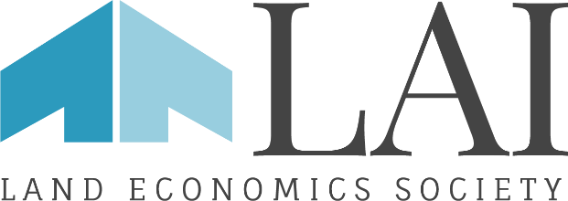
AWARDS NOMINATION FORM

Please submit the following information:
LAI Chapter President (nominator):

LAI Chapter:

Contact Information for Chapter President:

Name of Nominee:

Award Category:

Justification for nomination (1 page maximum, with headshot, please; photos encouraged for Skyline nominations)

Justification for nomination, cont.

Proposed Citation: (25 words if possible; we may edit for length)
In recognition of/for:

Please submit nominations and any questions to:
Sheila Hamilton – lai@lai.org
Executive Director
Lambda Alpha International
480-719-7404

