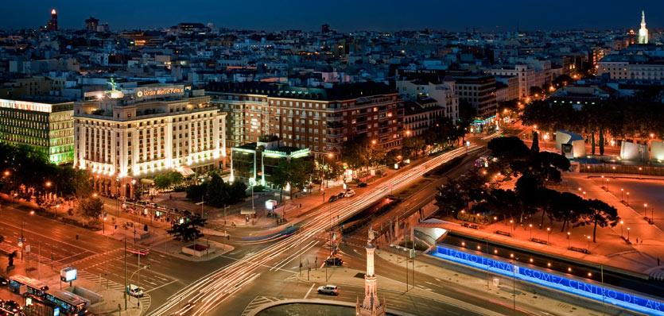

Business Meeting Agenda Grand Melia Fenix Hotel
October 15, 2014 Calle de Hermosilla, 2, 28001 Madrid

TIME | EVENT | ATTENDEES
8:00am-9:00am | Breakfast
9:00am-11:00am | LAI Executive Committee Meeting | LAI Executive Committee
11:00am-1:00pm | LAI Chapter Presidents Roundtable  -LAI Chapter Presidents share best practices and lessons learned | Chapter Presidents  1st Vice Presidents  Regional Vice Presidents
11:00am-1:00pm | Land Economics Foundation Executive Committee | LEF Executive Committee
1:00pm-2:00pm | Lunch
2:00pm-5:30pm | LAI Board of Governors & LEF Board of Trustees Meeting | LAI Executive Committee  LAI Chapter Presidents  LEF Executive Board
NOTE: All meetings are open to LAI Members.
Grand Melia Fenix Hotel – Reservations
Rooms must be booked online at
http://meetings.melia.com/en/LAMBDAALPHAINTERNATIONALECONOMICSWEEKEND.html#
A limited block of sleeping rooms have been reserved on a first come first served basis for LEW attendees at a discounted rate of $262.55/night. Prices are per guest room per night without breakfast. Rates are valid from October 8th through October 24th. Reservation deadline is August 31, 2014.
Cancellations between September 1 and September 29, 2014 will be charged 50% of the confirmed room nights. Cancellations after September 29, 2014 will be charged 100% of the confirmed room nights.
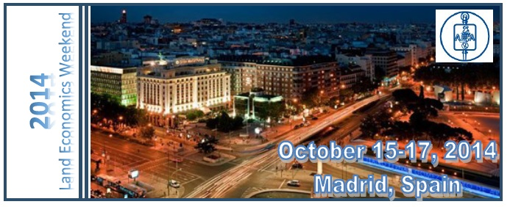
PROGRAM AT A GLANCE
TIME | EVENT | LOCATION
Wednesday, October 15
8:00am-9:00am | Breakfast | Grand Melia Fenix Hotel
9:00am-5:30pm | LAI Business Meetings | Grand Melia Fenix Hotel
7:00pm-9:00pm | LEW Begins/Tour | Torre Espacio
9:00pm-11:00pm | LEW Welcome Reception | Torre Espacio
Thursday, October 16
8:00am-9:00am | Breakfast | Grand Melia Fenix Hotel
9:00am-11:00am | LEW Presentations | Grand Melia Fenix Hotel
11:00am-1:30pm | Tour | New City Hall
1:30pm-4:00pm | Tapas, Drinks & Lunch | New City Hall
4:30pm-6:30pm | Tour | BBVA Bank
6:30pm-8:00pm | Tour | Telefonica
8:00pm | Dinner On Your Own
Friday, October 17
8:00am-9:00am | Breakfast | Grand Melia Fenix Hotel
9:00am-11:00am | LEW Presentations | Grand Melia Fenix Hotel
11:00am-1:30pm | Tour | New Real Madrid Stadium
1:30pm-4:00pm | Lunch on Your Own
4:30pm-6:30pm | Tour | Santander Bank
8:30pm-11:30pm | Closing Dinner | Casino de Madrid

